Cairo University  
Faculty of Computers and Artificial Intelligent

**CS251**

**Software Engineering I**

Garage System

Software Requirements Specifications (SRS)

Mariam Osama Ahmed

Fouad Sayed Fouad

Mohamed Sayed Ali

5 & 2022

Contents

Team 3

Document Purpose and Audience 3

System Models 4

I. Class diagrams 4

Important Algorithm 5

II. Sequence diagrams 6

Class - Sequence Usage Table 11

Ownership Report 12

# Team

|  |  |  |  |
| --- | --- | --- | --- |
| **ID** | **Name** | **Email** | **Mobile** |
| 20200519 | Mariam Osama Ahmed | mo086388@gmail.com | 01110981070 |
| 20200384 | Fouad Sayed Fouad | Foadsayed18@gmail.com | 01210950773 |
| 20200450 | Mohamed Sayed Ali | mohamedsayed415.ms@gmail.com | 01020467154 |

# Document Purpose and Audience

* This document tells us the class diagram and sequence diagram of this program.
* Audience → Customers who want to build a garage system.

# System Models

## I. Class diagrams

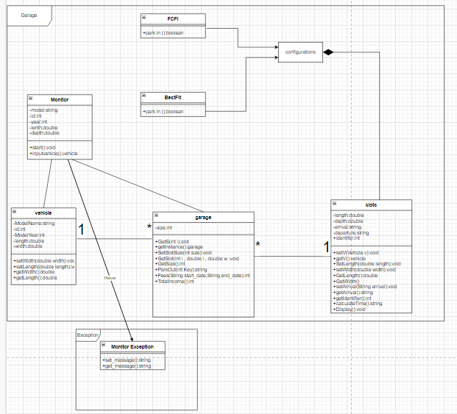



| **Class ID** | **Class Name** | **Description & Responsibility** |
| --- | --- | --- |
| 1 | Vehicle | set vehicle’s information |
| 2 | Owner | choose configuration  set number of slots |
| 3 | Receptionist | Park in  Park out |
| 4 | Slot | Set slot’s depth and width |
| 5 | Calc time | Calculate time |
| 6 | System | Set arrival time  Set departure time  Display available slots |
| 7 | Fees | Calculate fees  Calculate total income |

### 

### Important Algorithm

* none

## II. Sequence diagrams

1- Park in

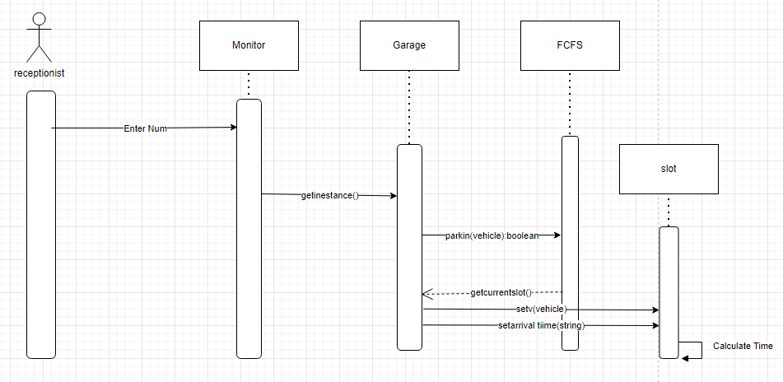

2- Display

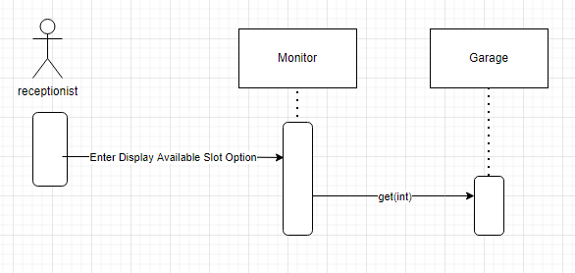

3- Fees



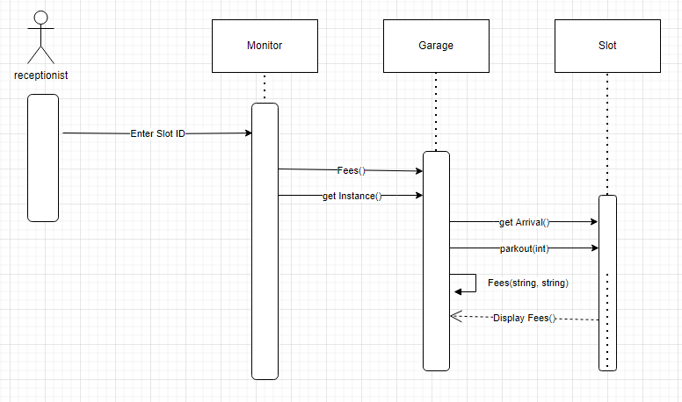

4- Park out



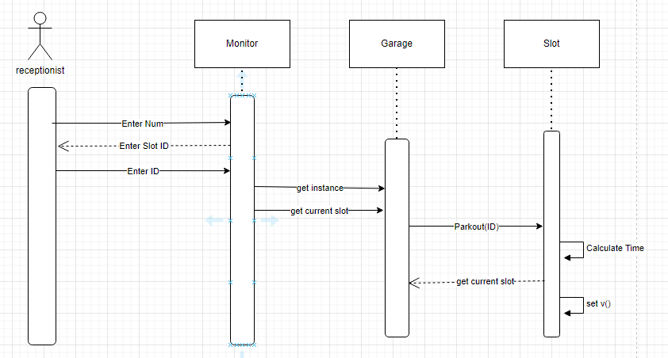

5- Total income



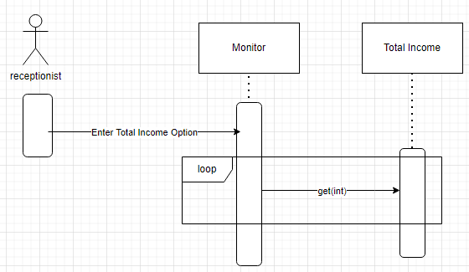

### 

### Class - Sequence Usage Table

| **Class Name** | **Sequence Diagrams** | **Overall used methods** |
| --- | --- | --- |
| Website | 1, 2,3,4,5,6,7 | * Log in * Clear password field * Enter vehicle data * Display available slots * Get configuration number * Display total time * Display fees * Display vehicle place * Display total income |
| System | 1,2,3,4,5,6,7 | * Retrieve available slots * Check if configuration number is valid * Give ID to vehicle * Calculate total time * Calculate parking time * Calculate fees * Retrieve vehicle place |
| Data base | 1,2,3,6,7 | * verify credentials * check for the data * store data * check for available slots * store configuration * store ID * look for vehicle ID * check for password |

# 

# Ownership Report

|  |  |
| --- | --- |
| **Item** | **Owners** |
| Class diagram/ implementation | *Mariam Osama Ahmed* |
| Class diagram/ implementation | *Fouad Sayed Fouad* |
| Sequence diagram/ sequence usage table/ implementation | *Mohamed Sayed Ali* |